**Tutorial 4**

1. Describe the concept of database and database management systems.

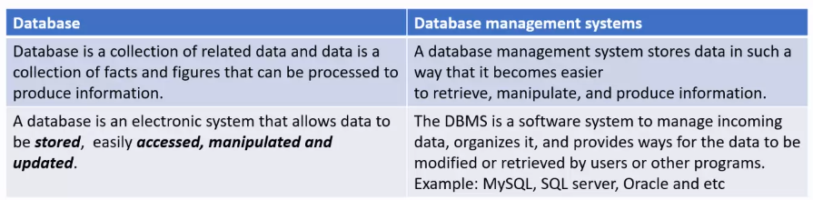

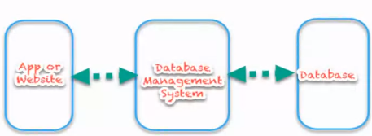

1. Write code to load a driver, connect to a database, execute statements, and process result sets using JDBC.

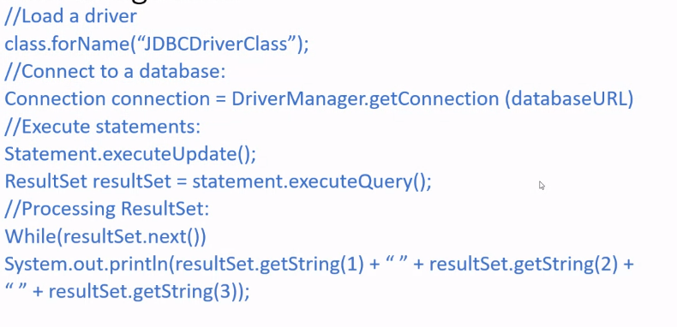

1. Use prepared statements to execute precompiled SQL statements (E.g.: SQL insert statement).

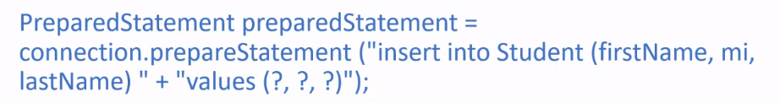

1. Using example, write SQL statement of **Create**, **update**, **delete** a new table row.

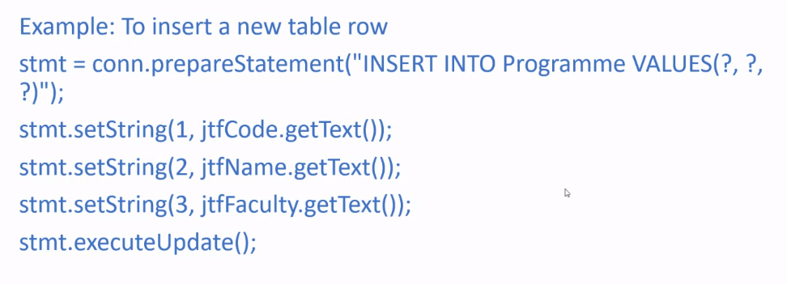

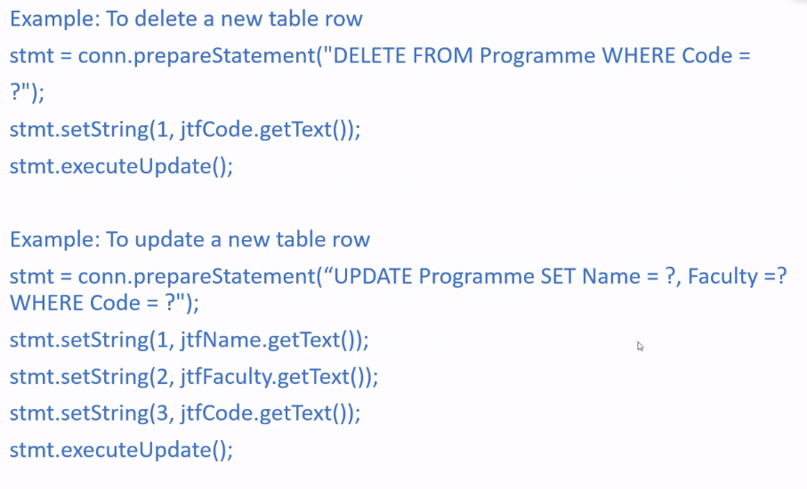

1. Explain the **purpose** of **MVC** framework (Model-View-Controller).

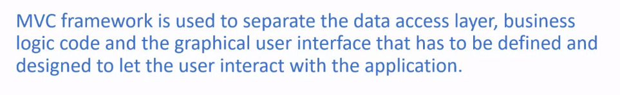

1. Describe **three** different **layers of MVC.**

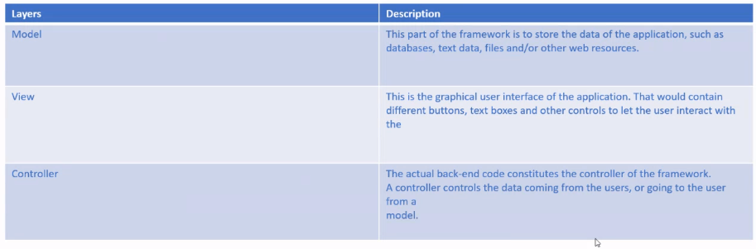

**MVC Process**

